The main content is in this link: https://wifi.scandocs.net/DS2800/en/mqtt

1、1. What is the exact QR code data format for WiFi + MQTT configuration? Please provide:
- The complete data structure/format (JSON? Plain text? Specific syntax?)
- All required fields and their exact names
- An example of a complete configuration QR code payload
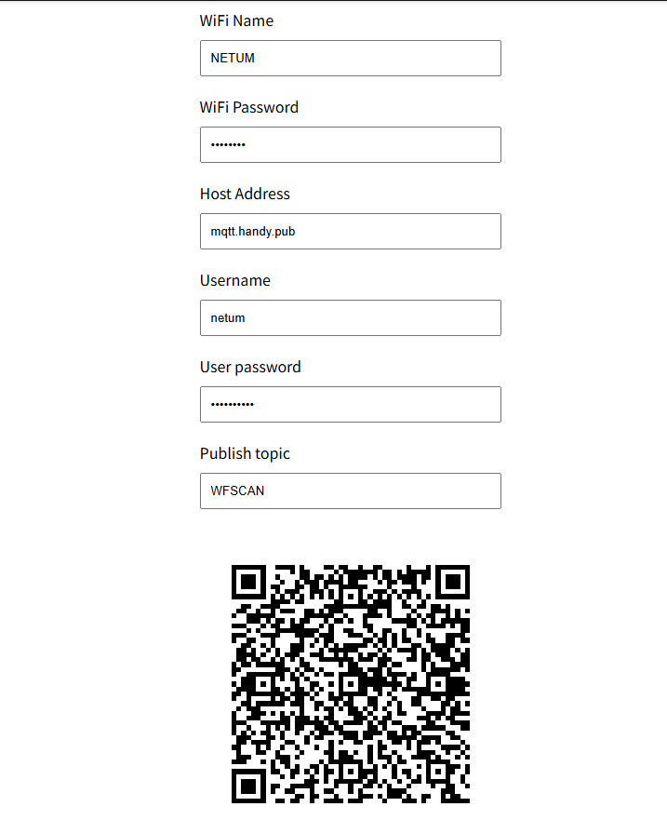
The content of the QR code:：AT+URL=2,mqtt.handy.pub,netum,netum@2022,WFSCAN;AT+RAP=NETUM,12345678
- AT+URL=2 MQTT format
- mqtt.handy.pub Host address
- netum User name
- netum Password
- WFSCAN Publish topic
- AT+RAP= WiFi configuration commands
- NETUM WiFi name
- 12345678 WiFi password
- , Grouping symbol

- Can all settings be combined into ONE QR code, or do we need multiple QR codes (one for WiFi, one for MQTT, etc.)?
A: The answer to question 1 is to combine all the content into a single QR code.

3. How do we set the id field (the scanner's identifier that appears in the data payload {"id":"C143F123","msg":"barcode"})?
- Can this be set in the same WiFi/MQTT configuration QR code?
- What is the field name/parameter for this in the QR code data?
A：You can set the ID via this link：
https://fast.scandocs.net/manual/WiFi/en/wireless#json-format-content2

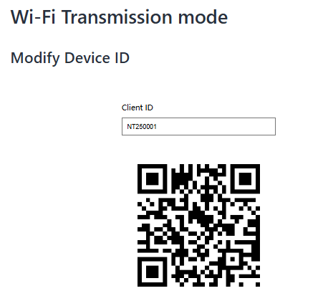

4. MQTT client_id configuration:
- Can the MQTT client_id be included in the configuration QR code?
A: Not supported at present.

What is the exact field name/parameter?
A：Refer to the QR code content in point 3.

Is it the same as the payload id field, or are they independent?
A：Each device has a unique ID and independently.

5.Factory reset: Does the scanner require scanning a factory reset barcode before scanning our configuration QR code?
A：You can choose to restore factory settings or not; both options are available. Scan and configure the settings according to your needs.

