1.
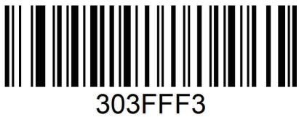
Restore Factory Defaults
2.
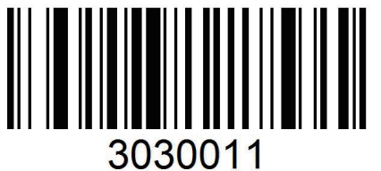
USB KBW*

3.
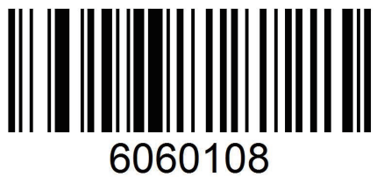
French Keyboard

4.

Hide specific type of barcode from front

3.Scan “Data Matrix(DM)” scan value: 1242
①

1 ②

2
③

4 ④
2

4.Hide 8 digits for datamatrix from front. Scan value 0 ,0,0,8
①

0

②
0
③
0 ④

8

5.Enable scanner to hide 8 digits for datamatrix
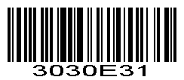
Enable scanner to hide digits from front.

6.

Hide specific type of barcode from behind

7.Scan “Data Matrix(DM)” scan value: 1242
①
1 ②
2
③
4 ④
2

8.Hide 16 digits from behind, scan value: 0,0,1,6
①
0
②
0

③
1

④

6

9.
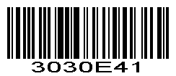
Enable Hide specific type of barcode from behind

