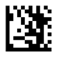
Enter Configuration

Disable QR

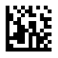
Exit Configuration

