1.
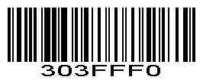

2.
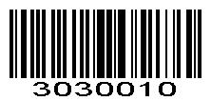

3.
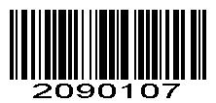

4.
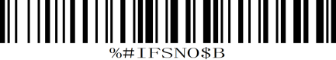

5.
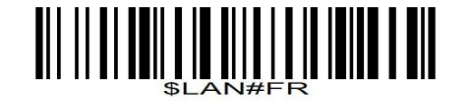
French Keyboard

6.
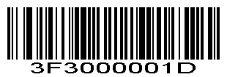
Hide specific type of barcode from front

7.Scan “Data Matrix(DM)” scan value: 1242
①
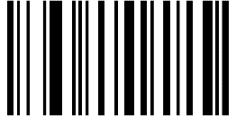
1 ②
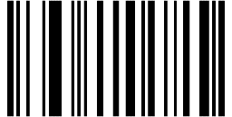
2
③
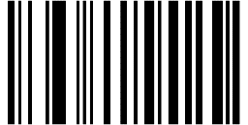
4
④
2
8.Hide 8 digits for datamatrix from front. Scan value 0 ,0,0,8
①

0

②
0
③
0

④
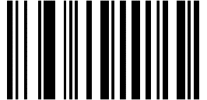
8

9.Enable scanner to hide 8 digits for datamatrix
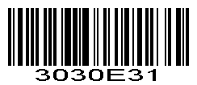
Enable scanner to hide digits from front.

10.
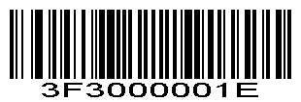
Hide specific type of barcode from behind

11.Scan “Data Matrix(DM)” scan value: 1242
①
1 ②
2

③
4 ④
2

12.Hide 17 digits from behind, scan value: 0,0,1,7
①
0
②
0

③
1

④
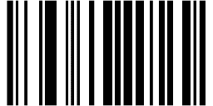
7

13.
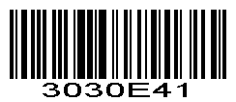
Enable Hide specific type of barcode from behind

