1.

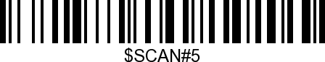
Hide Barcode Start Chars

2.
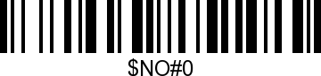

3.
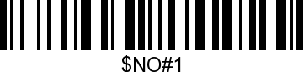

4.
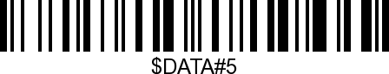
Enable Hide Barcode Start Char

